DATA ANALYTICS WITH R, EXCEL AND TABLAEU ASSIGNMENT Excel Analytics 30.1

ANSWERS

4. Associated Data Files

Use “Data.xlsx”

  - Problem Statement

- Using the excel spreadsheet “Data.xlsx”, create a series of Pivot Tables (or

Pivot Charts) to answer the following questions.

- What are the averages for purchases in each region?

Ans
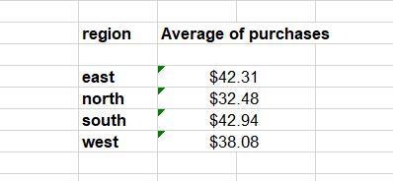

• What form of payment is most common?

Ans most common form of payment is by credit.

- Do our customers shop at work (most likely between 8:00 and 17:00) or at home?

Ans =IF(AND(HOUR(G2)>=7,HOUR(G2)<=18),"Work","Home")

Customer shop at work.

Note: To answer number 3, a new column is created in the spreadsheet labeled "Hour of Day" and set it to just the hour instead of hour and minutes. In other words =hour(G8). The students who are excel power users should use an "if" formula to create a value of either day (time between 8:00 and 17:00) or night (not between 8:00 and 17:00)

